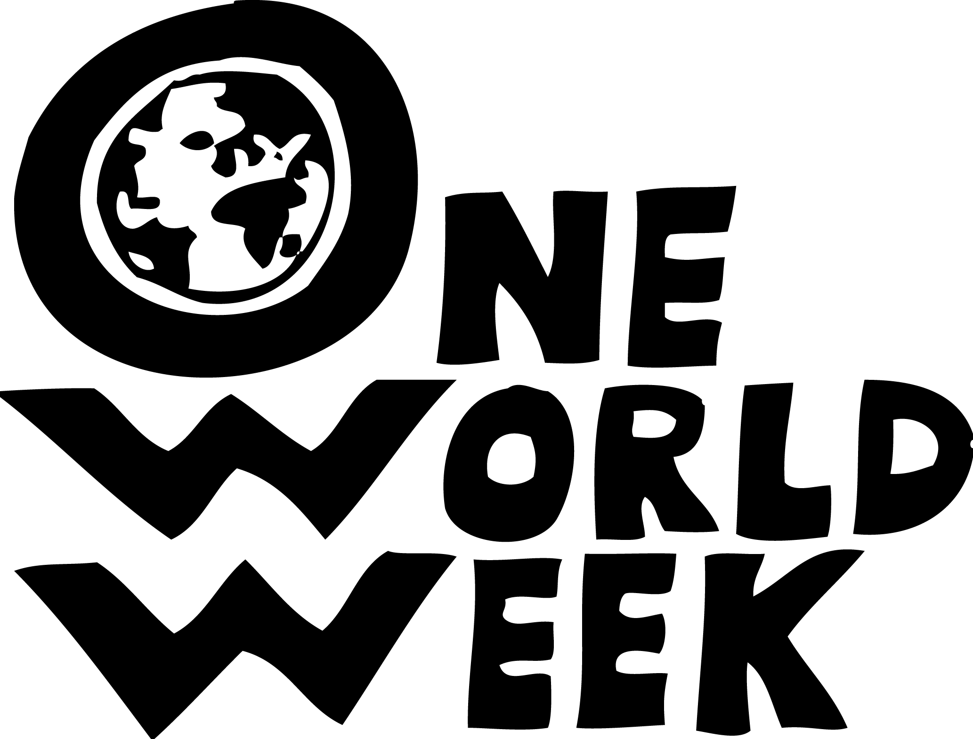 One World Week 18-25 October 2009
Hungry for One World

POWW (Portsmouth One World Week) invites you and your group to participate in an event that will recognise and tackle some of the needs in our local communities and global community.

OWW brings people together from diverse cultures, faiths and the general public to think about how we relate to each other in our one shared world and to explore what we can each do to help tackle the hunger we see in our world.
Hungry for what?
Food, shelter, education, comfort, laughter, joy, contentment, justice, acceptance, respect, well-being, peace, security, hope for the future...
• What do I hunger for?
• What do others hunger for?
• What does the world hunger for?

OWW encourages people, as individuals and communities, to think about how we relate to each other in our one shared world and how we can all play a part in tacking the hunger for well-being, justice, respect, peace and security to safeguard for future generations a world that is socially fair and environmentally sustainable.

POWW is a group of people from various faith and cultural groups, public services and voluntary organisations in and around Portsmouth.

You can find out more on the attached leaflet / poster and from the One World Week website, (www.oneworldweek.org ), which includes a PowerPoint presentation on what we’ve been doing in Portsmouth: (http://www.oneworldweek.org/v2/uploads/files/Portsmouth.ppt ) and various resources which you might find useful for your OWW.

POWW is planning a large event at which various interest groups from the Portsmouth area and nearby will set up a ‘fair’ of activity workshops (more below) encouraging people to explore what aspects of one world they are hungry for by:
- exploring: [e.g. what they and people around the world hunger for and what they are doing about it];
- understanding: [e.g. shared values of different faiths];
- telling / explaining / expressing [e.g. public speaking; poetry. artwork)
- celebrating our differences through: [e.g. cooking / eating / dancing / singing]

Could your group organise a ‘workshop’ involving either a celebratory or a participatory activity? We would like to see a mixture of workshops: some focussing on celebrating different cultures and others looking at global issues and what, we as individuals and groups, hunger and hope for and can do to help bring the one world family closer together. Groups could work on this theme in advance and bring their ideas to the share with others at the event or they could involve people on the day at the event in exploring and expressing their own ideas.

You may already be planning a OWW event of your own. If so we would love to hear about it and we can help publicise it. (See form below)

Would you be prepared to run on behalf of OWW in the Great South Run which takes place in OWW on Sun 25th October?

(POWW_10.06.09)
More about the proposed ‘Hungry for One World’ workshops

Workshops should include a global dimension using the ‘Hungry for One World’ theme in some way and encourage participants to consider some kind of change in their lives as a result of their new understanding.

The event will take place on Sunday, 18th October 2009 from 1.30 to 5.30 at the Hub, Dennis Sciama building Burnaby Road, Portsmouth.

Workshops could last most of the afternoon (eg a group artwork) or be shorter and repeated once or twice so people can visit and take part in more than one. We would hope to have a plenary session at the end to give each workshop a chance to share their findings with everyone present.

The POWW committee welcomes ideas and applications from all to run a workshop or demonstration. We shall need to select contributions that will fit into the space available and achieve a suitable balance for the event, so we may not be able to include all your ideas. Please use the attached form to express an initial interest in participating and we will then contact you again for further details.

If you’d like to come to our next planning meeting you’re very welcome. It’s at 5.30- 7.00 on 1st July in Portsmouth Civic Offices Room Conference Room L, 2nd Floor
_______________________________________________________________________

Your Name …………………………………………………………

Name of Group/organisation……………………………………………………………………………

Contact details: tel. ………………………………………email…………………………………………….
Address…………………………………………………………………………………………………………
…….………………………………………………………………………………………….
What your organisation does………………………………………………………………………….

……………………………………………………………………………………………………………

What you might be able to offer to the event on 18 Oct 09 [Brief indication only needed at this stage]
…………………………………………………………………………………………………………

………………………………………………………………………………………………………….

Are you planning to hold a OWW event of your own? yes / no / maybe [Please circle one]
If ‘yes’ would you care to give us some details so we can help publicise it?

Date……………………time………………………place……………………………………………………

Topic/ nature of the event…………………………..………………………………………………………..

Do you know of anyone who would run on behalf of OWW in the Great South Run?
Contact details please
………………………………………………………………………………………………………………….

…………………………………………………………………………………………………………………
Please return by the end of July to Portsmouth One World Week, 57 Roundway, Waterlooville PO7 7QD or to sarahhirom@tiscali.co.uk

(POWW_10.06.09)

